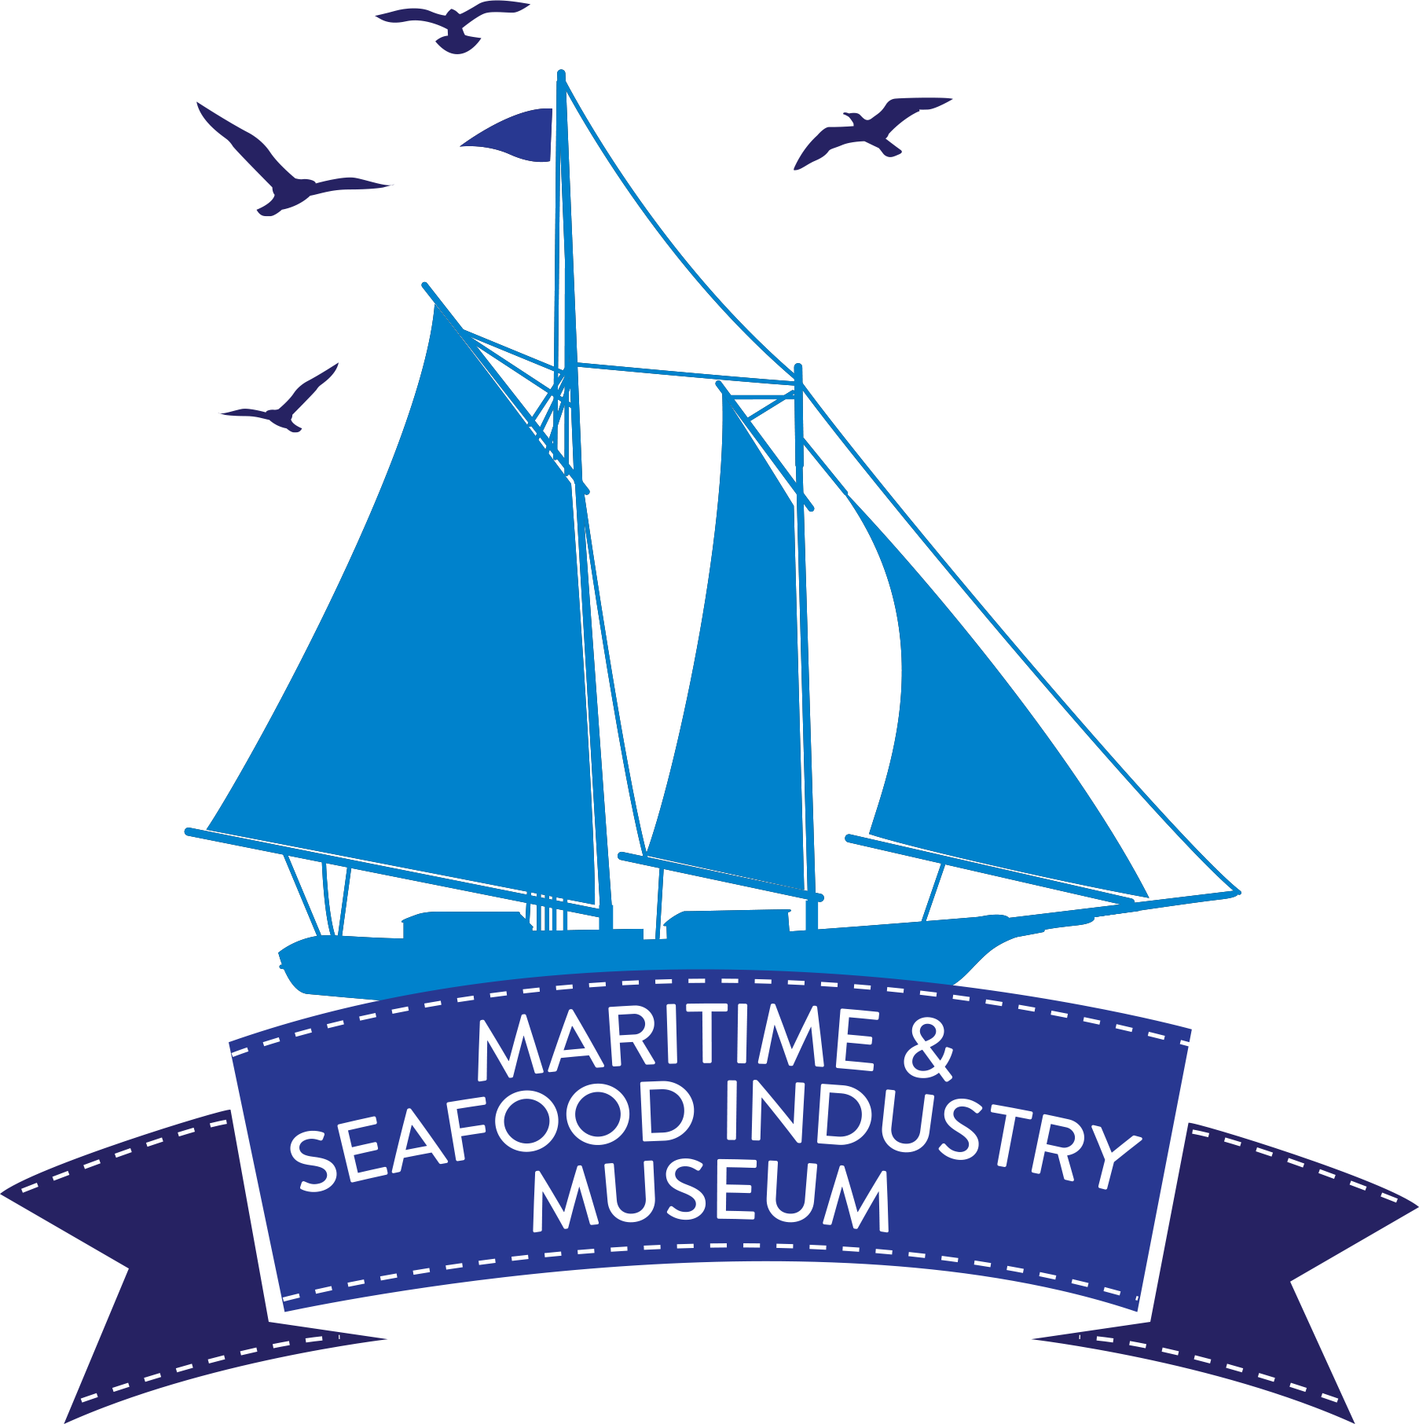
Maritime & Seafood Industry Museum
2026 Sea-n-Sail Adventure Camp

Experience the History and Heritage of the Mississippi Gulf Coast through Sailing Trips, Fishing, Maritime Crafts, and Seafood Industry Field Trips.

DAY CAMP SESSIONS
8:00 a.m. - 4:00 p.m. Monday – Thursday
8:00 a.m. – 1:30 p.m. Friday
Registration Begins January 19, 2026

June 1-5 July 6-10
June 8-12 July 13-17
June 15-19 (6 – 8 y/o only) July 20-24 June 22-26

Campers Ages 6-12 $275.00 per week
For More Information Call Elizabeth Alexander at (228) 435-6320

The Maritime and Seafood Industry Museum
115 1st Street, Biloxi MS 39530
Register online: www.maritimemuseum.org
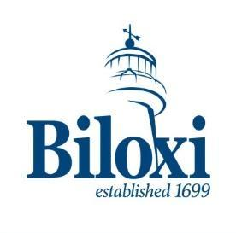

**This Project is supported in part by funding from the City of Biloxi and Mississippi Power

2026 SEA-n-SAIL ADVENTURE CAMP REGISTRATION

Name: ___________________________________ Date of Birth: ____/____/_____ Age at Camp: _______

Address: ___________________________________________________Email: _______________________

City: ______________________ State: _______ Zip Code: _________

Parent/Guardian Name and Phone Number: ____________________________________________________

Emergency Contact- Name and Phone Number: _________________________________________________

______________________________________________________________________________________________________________
T-Shirt Size (YOUTH): S - M - L or (ADULT): S - M - L - XL Circle One

Please Provide the Following:
- Does your child take any medication on a regular basis? If yes, please list:______________________

- Does your child have any known allergies? If yes, please explain: ___________________________

- Is it permissible to give your child/children Tylenol, if needed? _____ YES _____ NO

- Is your child required to wear a lifejacket on the Sailfish? _____ YES _____ NO
(The “Sailfish” does not require this per US Coast Guard)

Please check the session of camp desired (1st, 2nd, and 3rd choice): The Sea-n-Sail Adventure Camp will be offered from 8:00 a.m. to 4:00 p.m. during the following weeks:

____June 1-5 _____July 6-10

____June 8-12 _____July 13-17

____June 15-19 (6-8 y/o only) _____July 20-24

____June 22-26

PARENT/GUARDIAN CERTIFICATION FOR PARTICIPATION IS REQUIRED FOR ALL CAMPERS. REGISTRATION WILL BE VOIDED WITHOUT SIGNATURE.

This is to certify that as the parent/legal guardian of the above-named camper; I give my child permission for his/her participation in the Sea-n-Sail Adventure Camp. I further certify that I release from any and every liability, claim, right of action of any kind or nature which my child’s legal representative may have for any and all bodily or personal injuries or property damages and any other damages resulting there from which might occur during participation in this facility which this program is conducted.

PARENT/LEGAL GUARDIAN’S NAME (PLEASE PRINT): ________________________________________________________

PARENT/LEGAL GUARDIAN’S SIGNATURE: __________________________________________________________________

DATE: ________________________________________________________________

************************************************************************************************************
Please detach the above form and return with deposit to Maritime & Seafood Industry Museum at the following address:
Sea-n-Sail Adventure Camp
Maritime & Seafood Industry Museum
P.O. Box 1907
Biloxi, MS 39533-1907
FEES:
Cost per week is $275.00. A non-refundable pre-registration fee of $50.00 is required with the application, (this is part of the original total). Credit cards are accepted. The fee balance is due the first camp day of the week the child is enrolled. The total fee is acceptable at the time of registration. The camp fee includes all costs of instruction, class materials, admission fees at historical sites, and transportation. Families with three (3) or more participants will receive a 20% discount, (this comes off of balance after deposit).

FOR ADDITIONAL INFORMATION CONTACT THE MUSEUM AT (228) 435-6320 OR EMAIL US AT outreach@maritimemuseum.org

Purpose of the Camp
The history and heritage of the Mississippi Gulf Coast extends back to the arrival of the French over 300 years ago. The Sea-n-Sail Adventure Camp is a day camp that is designed to bring about a greater awareness of our original history and maritime heritage through a variety of fun and educational activities. The camp is offered by the Maritime & Seafood Industry Museum of Biloxi, Inc., and is open to 6-12 year old students.

Camp Structure
The Sea-n-Sail Adventure Camp consists of a week of activities. Seven sessions will be held during the summer. Daily activities will begin at 8:00 a.m. and end at 4:00 p.m. Monday- Thursday and 1:30 p.m. on Friday. Campers will be grouped according to age: 6-8 and 9-12 year olds. Camp staff for each group will include an instructor and two (2) teaching assistants who are CPR/First Aid certified.

Daily Activities
All daily camp activities will originate at the museum located at 115 1st Street, Biloxi. Campers will be transported by bus to and from all fields of activity. Individual activities will range from one to four hours in duration. Camp activities include a variety of unique hands-on experiences which will make regional history and heritage come alive. The camp will begin with a welcome orientation on Monday morning. At this time, campers will meet staff members and be divided into groups. Campers must provide their own lunch and snacks. At times, lunch will be at a field trip or on board one of the schooners.

CAMP ATTIRE AND NECESSARY ITEMS:
Dress during camp week is casual with shoes required. Rain gear and a change of clothes can be left at the museum, if desired. We will not stop activities due to rain. Soft soled shoes are required on sail days. Hats and sunscreen are very important items every day, as well as a lunch and drinks. All campers must be signed in AND signed out each day by a parent or guardian specified on Parental/ Guardian Permission Sheet.

The Glenn L. Swetman/The Mike Sekul
All Sea-n-Sail Adventure Campers will take sailing trips aboard one of the Museum’s famous replicas of the Biloxi Schooner. Age group 9-12 will take a full day trip to Horn Island through waters fished by Biloxi fisherman for over 200 years. Campers age 6-8 will visit Deer Island during one of their half day sails and learn about marine pollution. During the sail, campers will learn components of sailing a schooner, boating safety and rules of the road, and participate in many sailing activities. Lifejackets are required on all students.

CLASS DESCRIPTIONS
Shrimping Experience – Campers will experience a living marine adventure on board a shrimp trawler, the Sailfish designed to demonstrate the how, why & what is caught by local fishermen.
Model Boat Building – During the program period, campers will learn how wooden boats are constructed. Working in small groups, campers will participate in the designing and building of scale model boats.
Crabbing/Fishing/Cast Netting – Campers will get to see crab pot demonstrations while at the pier complex. All campers will learn and employ the methods of Gulf Coast fishing on actual fishing trips. This includes learning how to throw cast/brail nets as well as learning the importance of these nets to the Mississippi Gulf Coast.
Field Trips – Campers will experience fun and educational field trips along the Gulf Coast. Locations include the Lynn Meadows Discovery Center, the MS Aquarium, the Institute of Marine and Mammal Studies, and swimming to name a few. We will also have storytelling by Native American Grayhawk, and oyster shell painting. Other activities are being planned.
Punch & Cookies Reception/Awards Presentation – On Friday of each week parents, grandparents, and guardians are invited to attend a reception beginning at 1:00 p.m. to see the presentation of trophies and awards for the many camp activities which took place during the week. This takes place at the Maritime & Seafood Industry Museum, 115 First Street, Biloxi.

REQUIRED PARENTAL AUTHORIZATIONS

Sea-n-Sail Adventure Camp Summer 2026
Please complete, sign and date each of the permission sections below:

CHILD’S NAME: _________________________________Week of Camp:______________

The following people, including parent/guardian, may pick up and drop off my child. Photo identification will be required. Any person not listed below will not be allowed to check out your child.

Signature: ________________________________ Date: _______________________

PHOTOGRAPHY PERMISSION
I ___ do ___do not give permission for my child as named above to be photographed or videotaped during Sea-n-Sail Adventure Camp. This includes photos that may be used for promotional or publicity purposes.
Signature: _________________________________ Date: _______________________
FIELD TRIP PERMISSION
My child, as named above, has permission to participate in any and all field trips that are a part of Sea-n-Sail Adventure Camp.
Signature: ________________________________ Date: _______________________
EMERGENCY MEDICAL TREATMENT
The Sea-n-Sail Adventure Camp has permission to obtain emergency medical treatment
for my child, as named above.
Signature: ________________________________ Date: ________________________

We have a zero-tolerance policy to bullying.
Signature: ________________________________ Date: _______________________

IMMUNIZATION VERIFICATION
This information is required for our files. Failure to supply this information will make your child ineligible for Sea-n-Sail Adventure Camp attendance, as required by the MS State Dept. of Health.
I verify that my child as named above has received all age-appropriate immunizations.

Signature: ___________________________________________Date: ________________

Doctor or Clinic: _____________________________________Phone: ________________

Address: __________________________________________________________________

Please list any known allergies: ________________________________________________

Is your child taking any medications of which we should be aware? Please list: ____________________________________________________________________________

COVID-19 DISCLAIMER AND RELEASE

The Museum is taking reasonable precautions to reduce the risk of exposure or spread of the novel COVID-19 virus by and among camp participants. Notwithstanding these efforts, by signing this form below you acknowledge the potential risk of exposure to the novel COVID-19 virus to you and/or your children and release the Museum from any and all liability or damaged, monetary or otherwise, associated with the exposure and/or treatment of said virus.

Signature: ________________________________ Date: ________________________

